GOOG = Alphabet

Business Model:

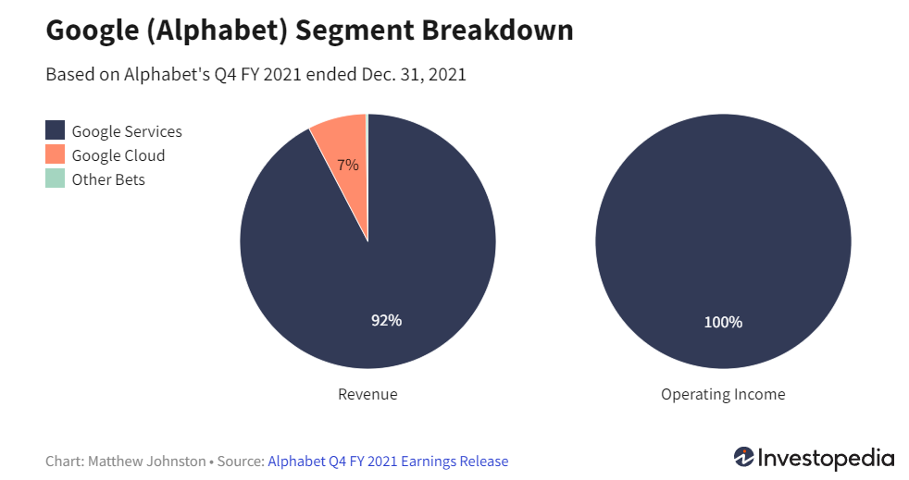

The Google Services segment is comprised of a range of products and services, including **ads, Android, Chrome, hardware, Google Maps, Google Play, Search, and YouTube**. The segment generates most of its revenue from **advertising**. Other sources of revenue include sales of apps, in-app purchases, digital content products, hardware, and fees received for subscription-based products such as YouTube Premium and YouTube TV.

ETF Funds?